Employee Data Import Using Import Sets and Transform Maps in ServiceNow
Documentation

1. Overview
This section describes how employee information is imported into ServiceNow from a spreadsheet using Import Sets and Transform Maps. The spreadsheet holds employee details: Employee ID, Name, Email, Department, and Location. The import loads this data into the Employee table, creating new records and updating existing ones without manual entry.

2. Objective
- Load employee data from a spreadsheet into ServiceNow in bulk.
- Validate the data in a temporary table before it reaches production data.
- Prevent duplicate employee records by using Employee ID as the unique identifier.
- Update existing employee records and insert new ones in a single import.

3. Components Used
Component | Purpose
Data Source | Points to the uploaded spreadsheet (.xlsx or .csv) and defines how the file is read
Import Set Table | Temporary staging table that stores the raw spreadsheet rows
Transform Map | Defines how staging table fields map to target table fields
Target Table | The Employee table, where the final records are stored
Coalesce | Field setting that identifies whether a record already exists

4. Process Description

Step 1: Upload the spreadsheet
The spreadsheet is attached to a Data Source record. Its column headers (Employee ID, Name, Email, Department, Location) define the fields of the import.
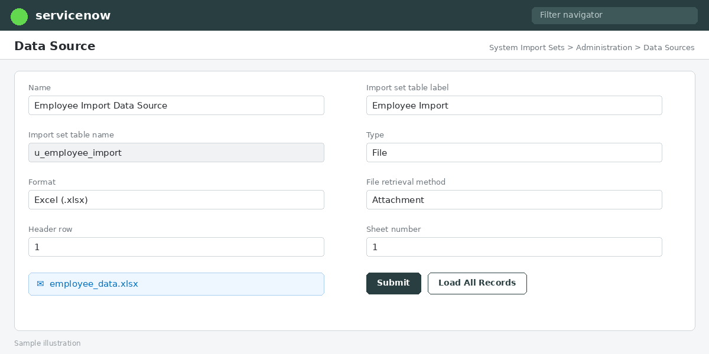
Figure 1: Data Source with the attached spreadsheet (sample illustration)

Step 2: Load data into the Import Set Table
The rows are loaded into an Import Set Table, a temporary staging area with one column per spreadsheet header. Because the data is held here first, it can be checked and validated without affecting the Employee table.
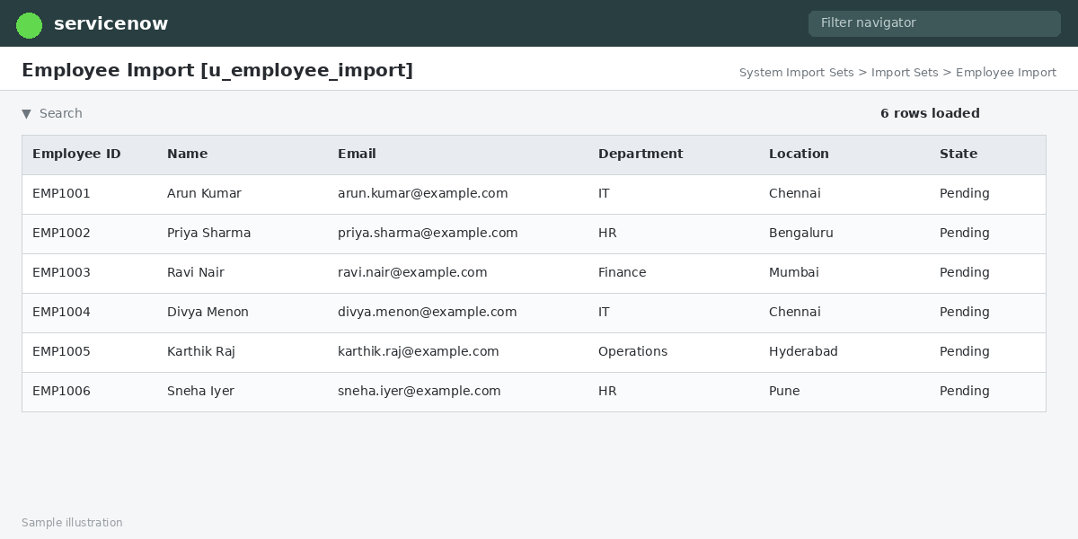
Figure 2: Import Set Table with staged employee data (sample illustration)

Step 3: Apply the Transform Map
The Transform Map links each staging field to the matching field in the Employee table:
Spreadsheet / Staging Field | Target Employee Field
Employee ID | Employee ID
Name | Name
Email | Email
Department | Department
Location | Location

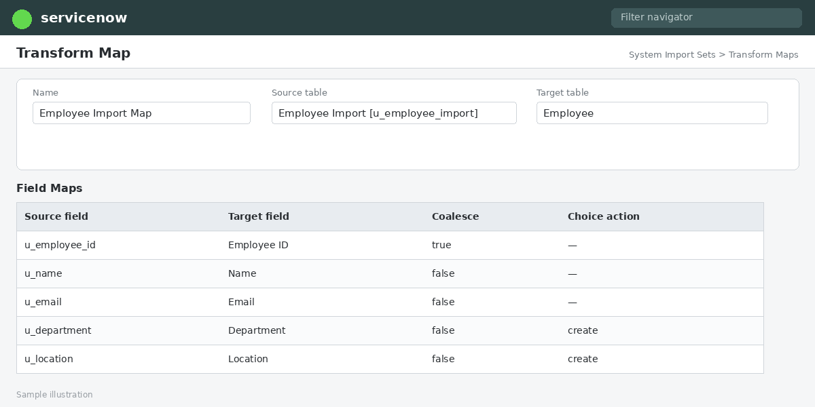
Figure 3: Transform Map field mappings (sample illustration)

Step 4: Identify existing records with Coalesce
The Employee ID field map is marked as Coalesce, so the system uses it as the unique identifier:
- If a record with the same Employee ID exists, it is updated with the new values.
- If no matching record is found, a new record is inserted.
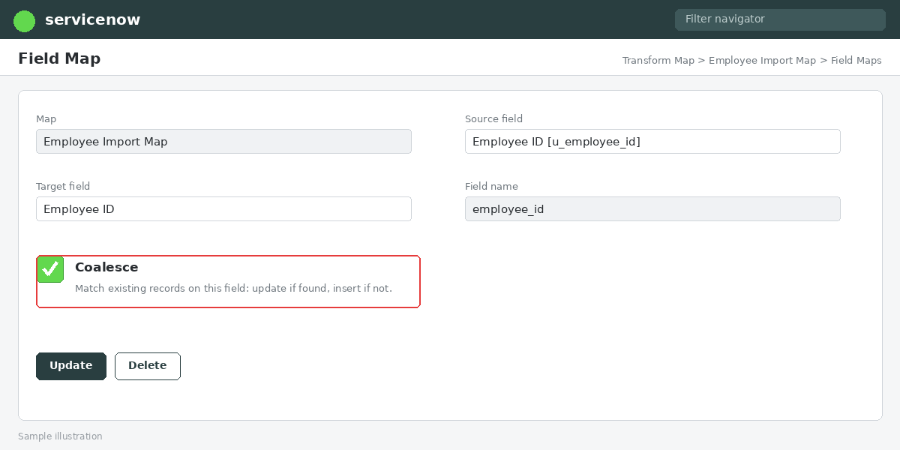
Figure 4: Coalesce enabled on the Employee ID field map (sample illustration)

Step 5: Review results
Each row is marked as inserted, updated, ignored, or error. The Import Set Rows and Transform History are reviewed to confirm the import worked as expected.
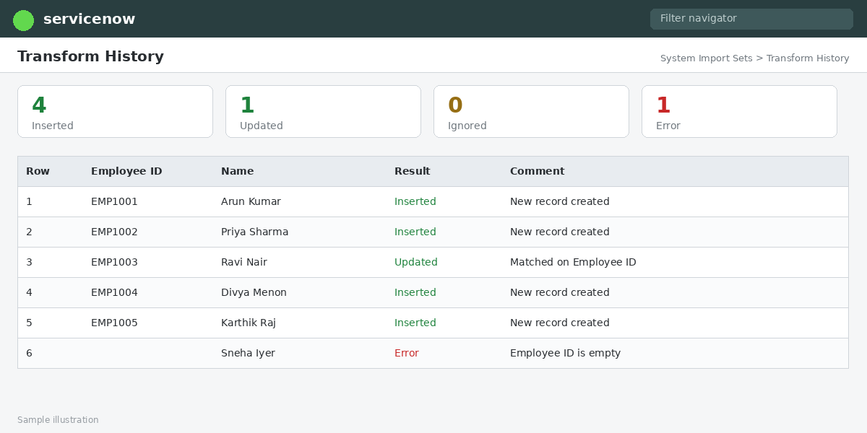
Figure 5: Import results in Transform History (sample illustration)

5. Data Validation Considerations
- Employee ID: must be present, unique, and consistently formatted (no trailing spaces, no leading zeros lost in Excel), since it drives the coalesce logic.
- Department and Location: these are usually reference fields, so the values must match existing records, or be created or resolved during the transform.
- Email: should be checked for valid format and can be normalized to lowercase in a transform script.
- Testing: a small sample file should be imported before the full dataset.

6. Advantages
- Bulk import of employee data reduces manual effort and entry errors.
- The staging table allows data to be checked before it affects live records.
- Coalesce on Employee ID prevents duplicates and supports updates.
- The process is repeatable for future employee data loads.

7. Conclusion
Import Sets and Transform Maps give ServiceNow a controlled way to bring spreadsheet data into the Employee table. The Import Set Table handles temporary storage and validation, the Transform Map handles field mapping, and coalescing on Employee ID makes sure existing employees are updated while new ones are added.

